Sphero Diary #2 week

1. I will find how Sphero actually moves <https://www.youtube.com/watch?v=1S5lUDvlu3A>
2. I will design the Sphero mounter (Design by my opinion by using wood and wheels toys)

This one is my inspiration <https://www.youtube.com/watch?v=JsOwyzG62OM>

**** If there is something wrong I will ask my friend to using 3d printer

1. However, I still need to find a code to the Sphero

And I found the **oval languages (subset of the C languages)** for the Sphero robots

<https://sprk.docsapp.io/docs/get-started>

and this one will help me.

1. This is Sphero Edu and I think it can help me, and there is community hub in there to help me.

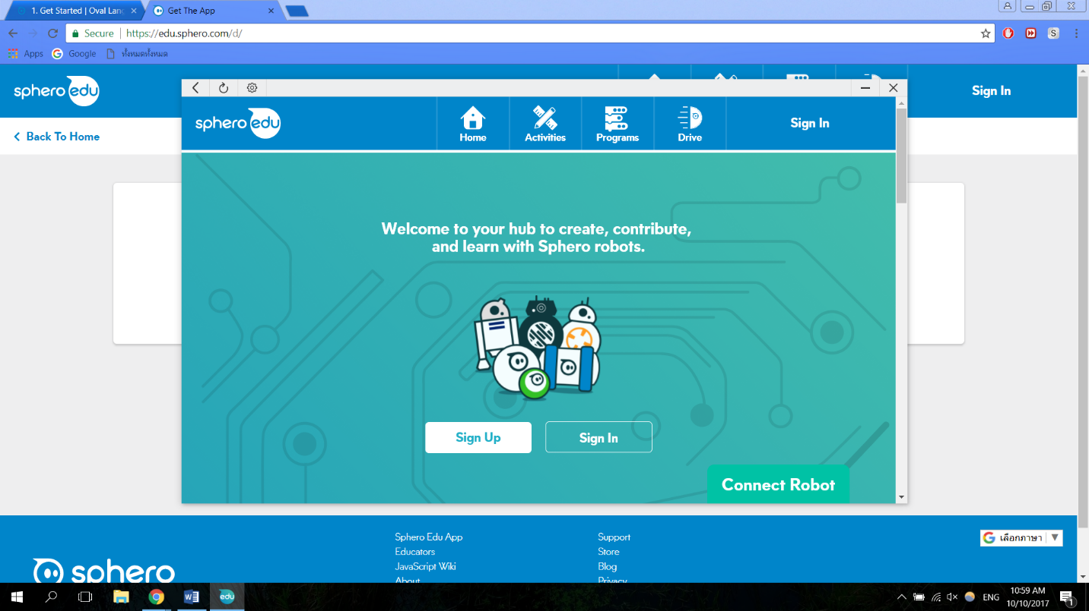

1. 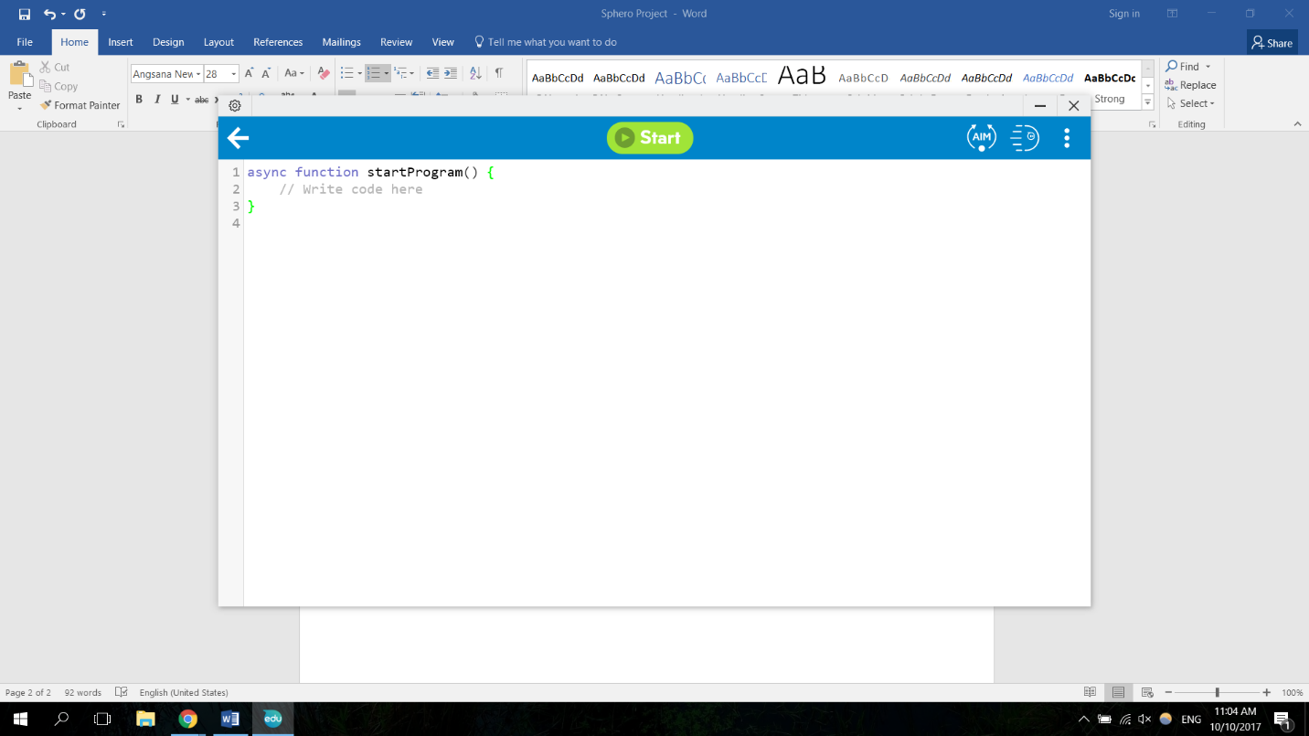This one is Javascript, but it is worth to learn and try.
2. 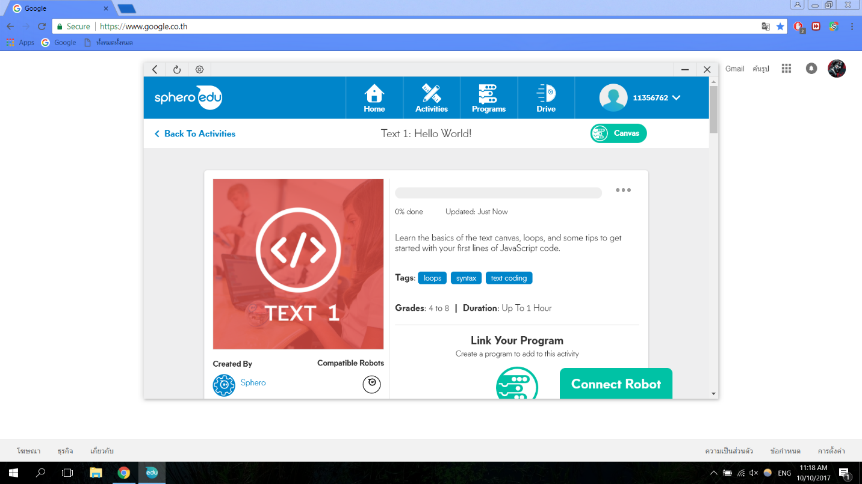Learning this thing in Sphero edu
3. 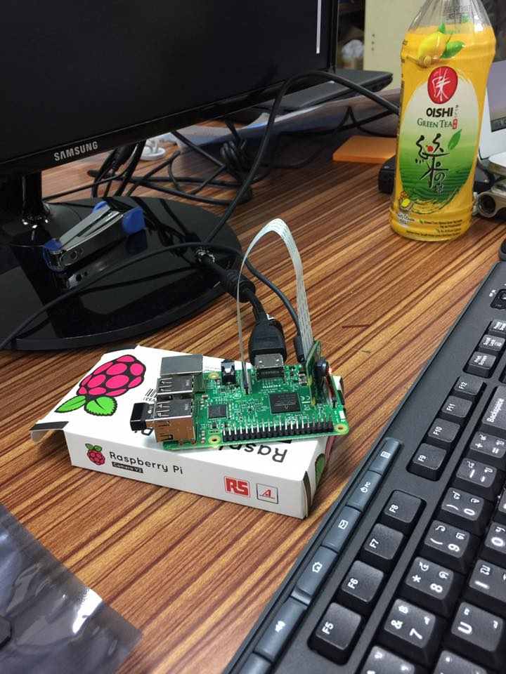Now, we have test the camera modules of the raspberry
4. This is an example of the camera modules testing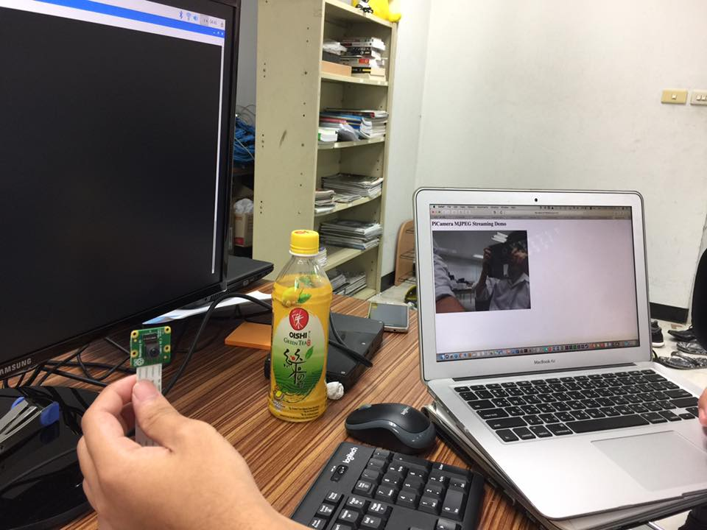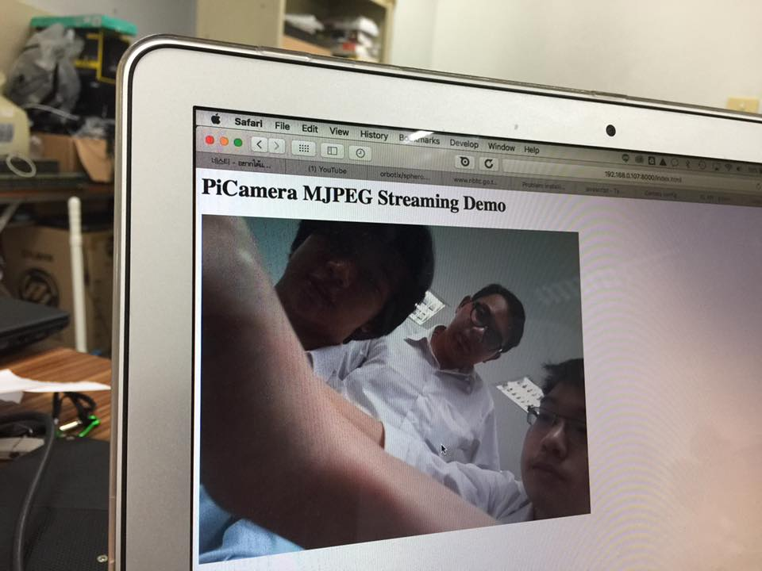
5. <https://www.youtube.com/watch?v=TgUQCSk3nUE>

This video is inspiring us about streaming the video in the website.

1. This is one of the mounting prototype

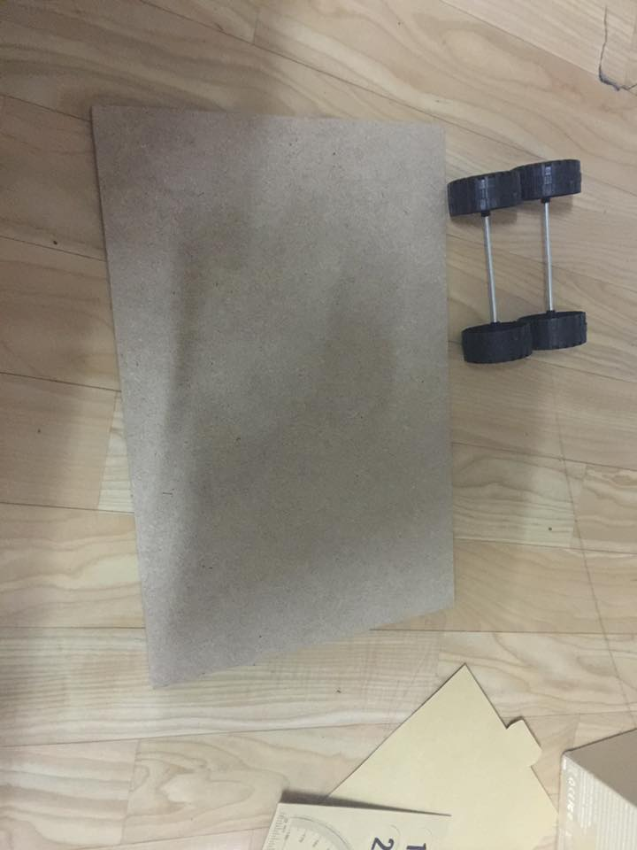

1. This is our plan to deal with.